Translation

Assessment Statements
- Explain the process of translation, including initiation, elongation, and termination
- Convert a DNA sequence into a mRNA and a protein sequence (with the help of a codon table)
- Show the way from DNA to membrane protein in a cell

Gene expression – an overview
A gene is a part of the DNA. It contains information encoded in a sequence of bases. As the DNA is essential for the cell, working copies of specific genes are produced - the mRNA. This mRNA now can leave the nucleus and meet a ribosome (after being processed in eukaryotes). There the information is translated into a sequence of amino acids. This chain of amino acids forms a shape in space – a protein which can serve as a structural element or as an enzyme.
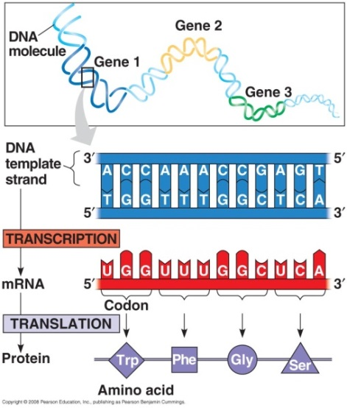
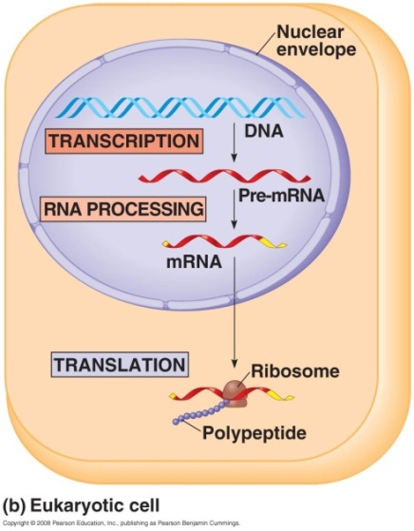

Vocabulary
amino acid: building block for proteins, there are 21 different amino acids
codon: group of 3 bases which contain the information for 1 amino acid
anticodon: corresponding 3 bases on complementary strand. e.g., ACG for UGC
3’ and 5’ end: both ends of a DNA or RNA strand. If the strand starts with 5’, there is 3’ on the other side. If a strand finishes with 5’, the end of the complementary strand is 3’. (‘-notation comes from the position at the sugar of the backbone)
polypeptide: chain of amino acids, a small protein

Important components
The ribosome | tRNA
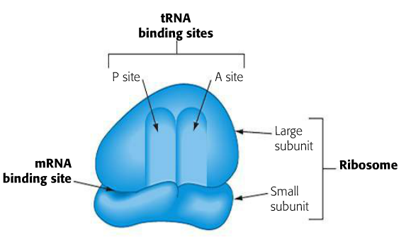 | 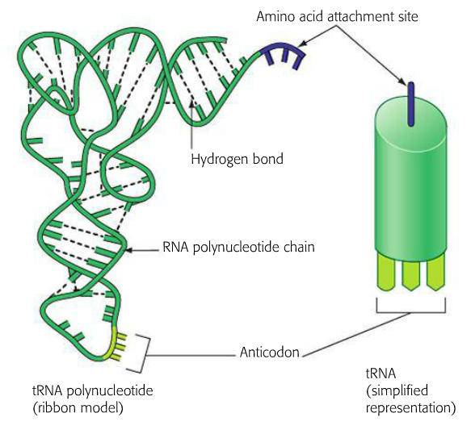

List all types of RNA with name and function

The translation process

1. Initiation

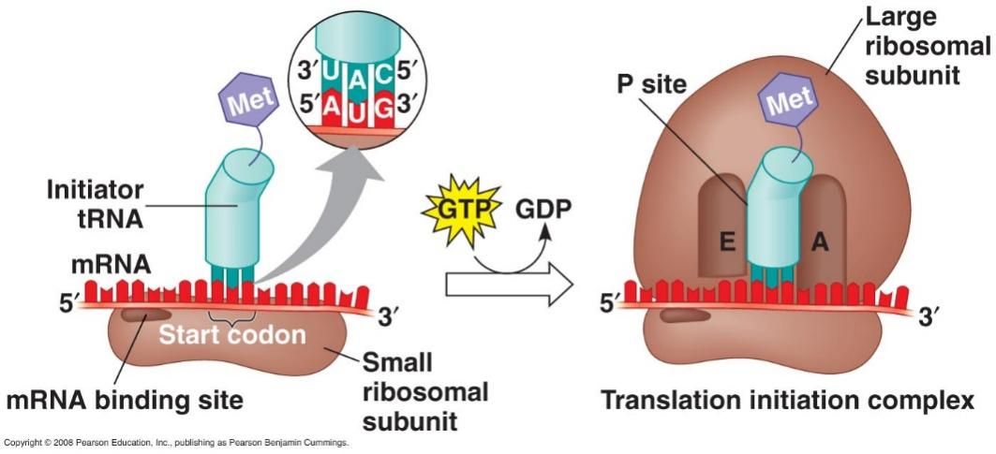

2. Elongation

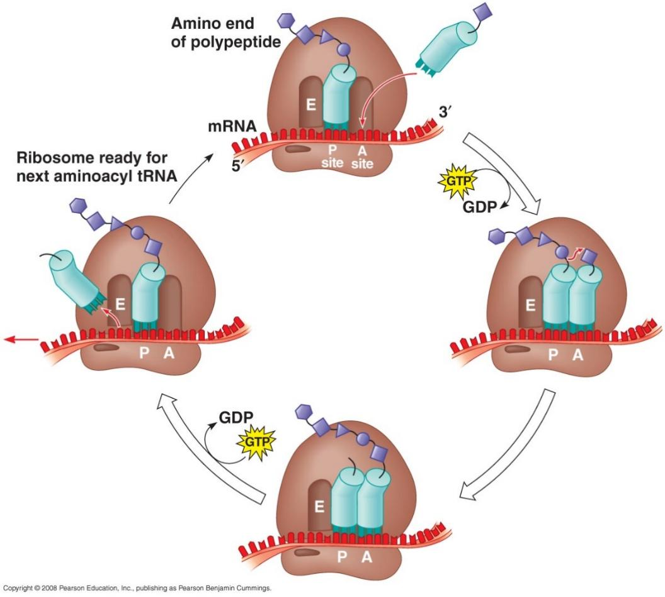

3. Termination

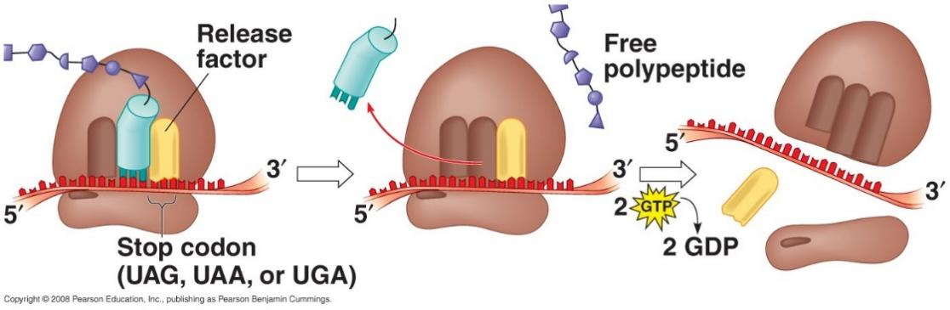

Amino acids

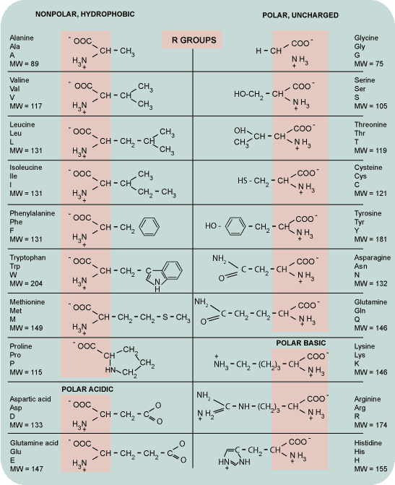

Codon Table
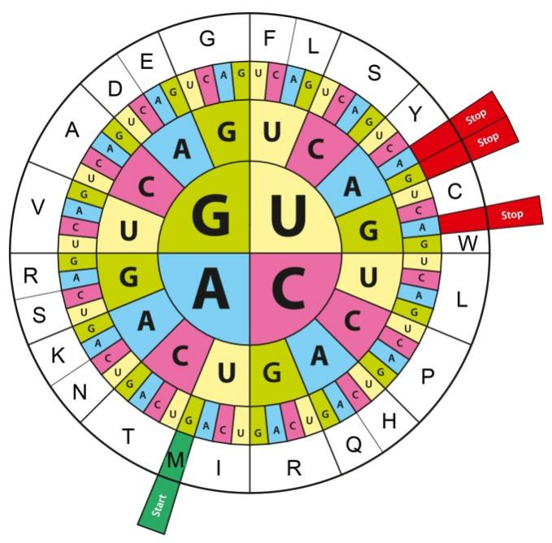

With this illustration we can translate an mRNA code into protein code. For each codon triplet, the corresponding amino acid has to be searched in the figure.
For the example of UAC, the first base is a U, so we look in the inner circle for U. Now we only look in the right upper corner for A in the middle circle. Now the last circle leads to C and the amino acid Y (Y is the one letter aberration for tyrosine).

Task
Take the following DNA sequence and rewrite it in mRNA and in protein code (DNA is non-template strand):
DNA: ATG TGG GAA ACT ACT ATT AAT GGT GAA AAT
mRNA: AUG UGG GAA ACU ACU AUU AAU GGU GAA AAU
Protein: Start WETTINGEN

Summary

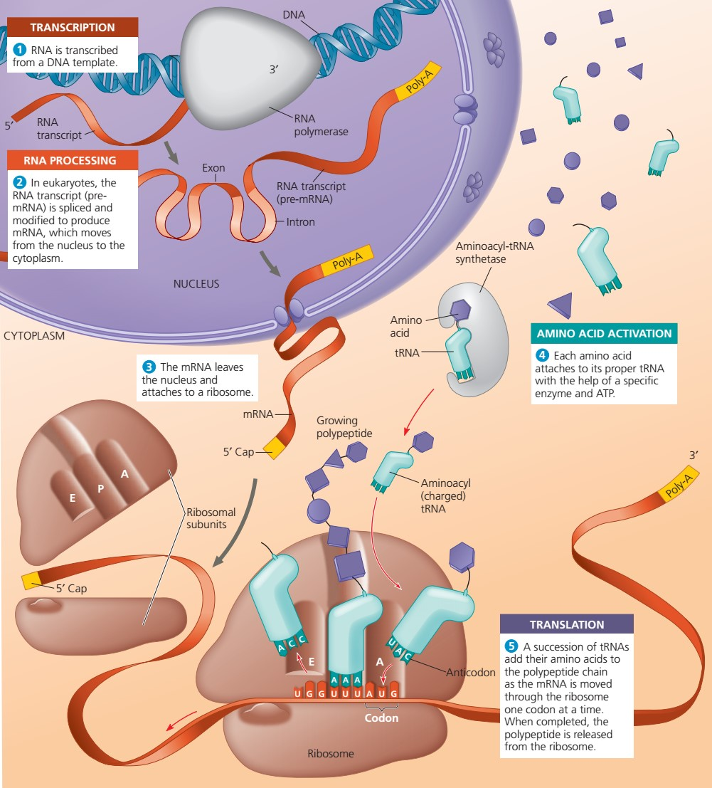

From gene to protein – ways in the cell

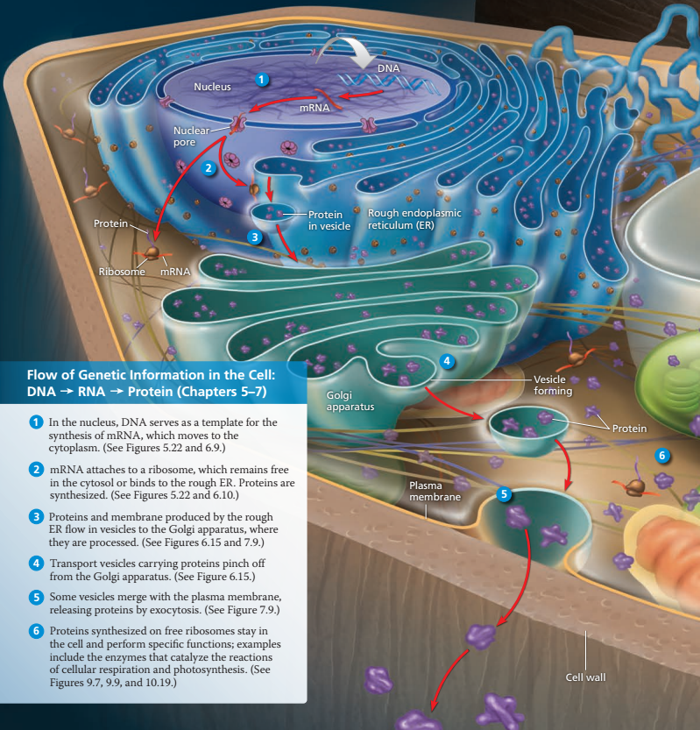

Post-translational modifications
For some proteins, the production is finished after translation. For other proteins, further modifications have to be done:
- Proper folding in 3D-space
- Cleavage
- Attachment of sugars, lipids
- Transport to an organelle, into a membrane or outside the cell

Protein structure
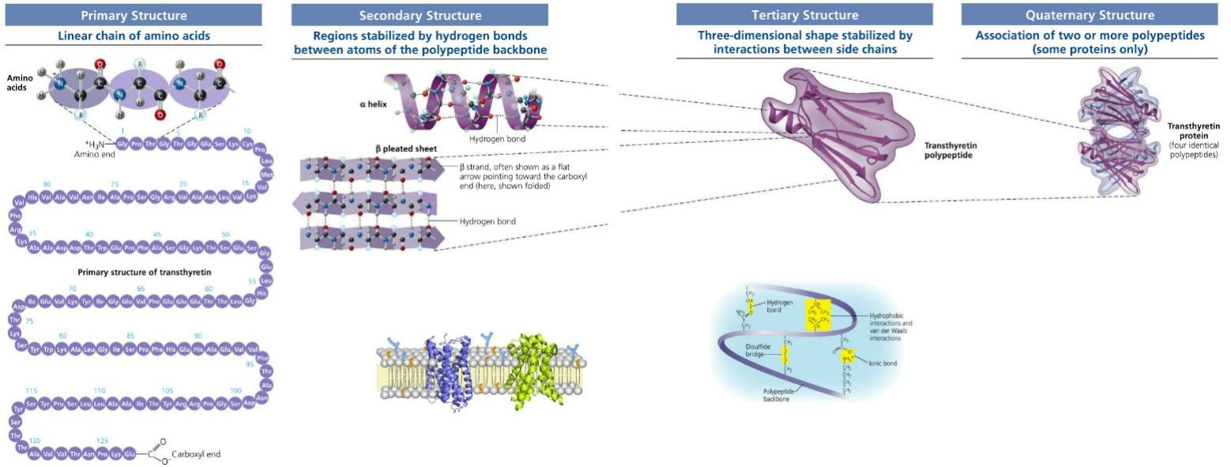

Used Tools and References
- Eckebrecht, D. et. al. (2018). natura 9-12, Grundlagen der Biologie für Schweizer Maturitätsschulen. Klett und Balmer AG.
- Reece, J. B. et al. (2018). Campbell Biology. (11th edition). Pearson Education.
- Simon, E. J., Reece, J. B., Dickey, J. L. (2013). Essential Biology with Physiology. (4th edition). Pearson Education.
- Clegg, C. J. (2023). Biology for the IB diploma. (3rd edition). Hodder Education.
- www.tokressource.org

CC BY 4.0 DEED for contents created by Daniel Margadant
For other sources (e.g., figures) please consider © of corresponding reference

